UI Design

**Main menu screen**

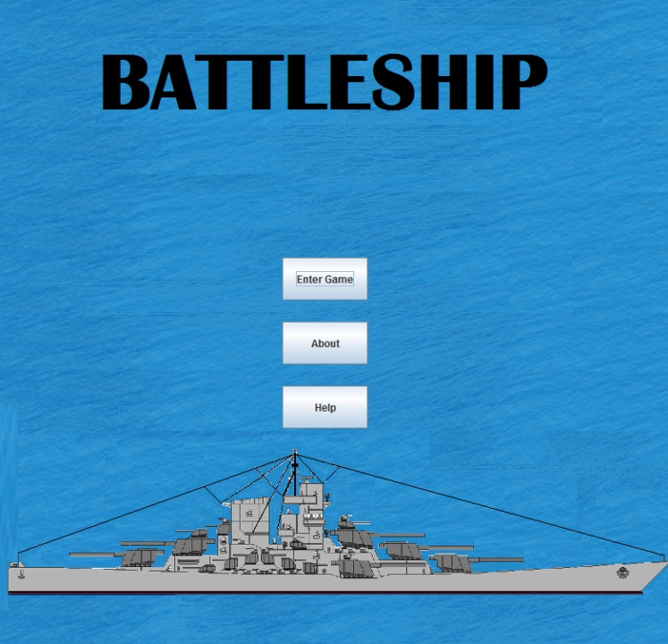

Press this button to enter into about screen

Press this button to play the game

The button leads you into help screens

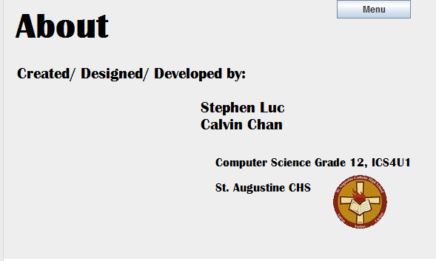 **About screen**

This is the about screen that tells you who made this program and from where

This leads you back to the main menu

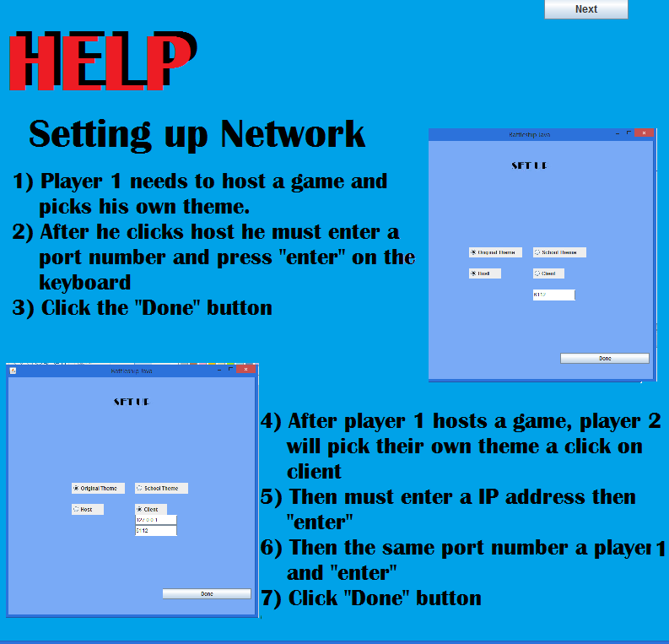**Help screens**

Brings you to the next help screen

This help screen helps describe how to start up the network

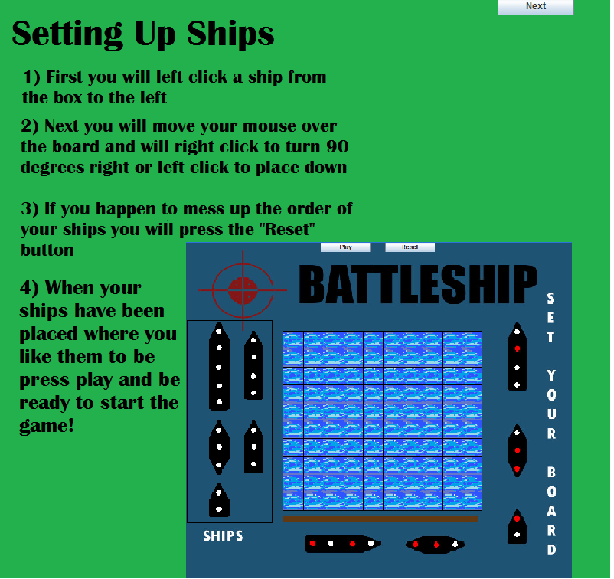

Bring you back to the last help screen

This help screen is how to set up your ships

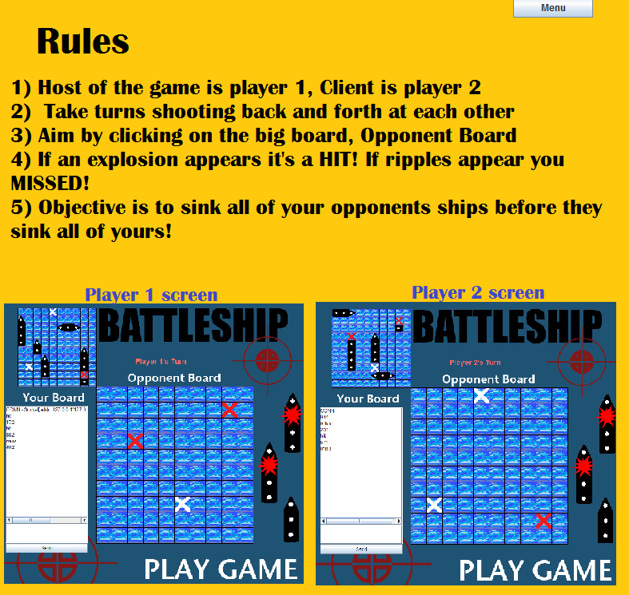

Brings you to the main menu screen

This screen is the rules how to play the game

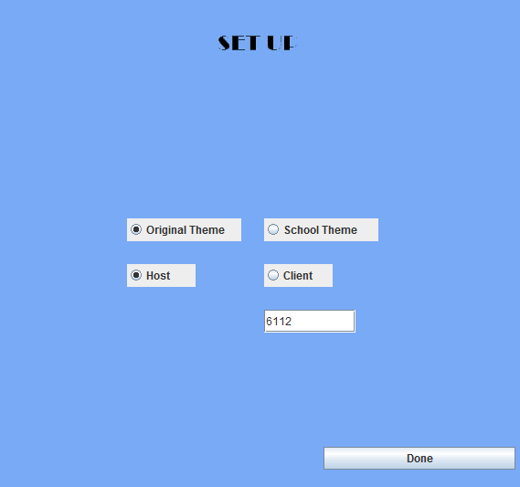**Set up screen/ Theme pick**

This allows you to pick the original battleship theme

Press this when you are done choosing theme and if you are host or client

Click this button to become host of the game

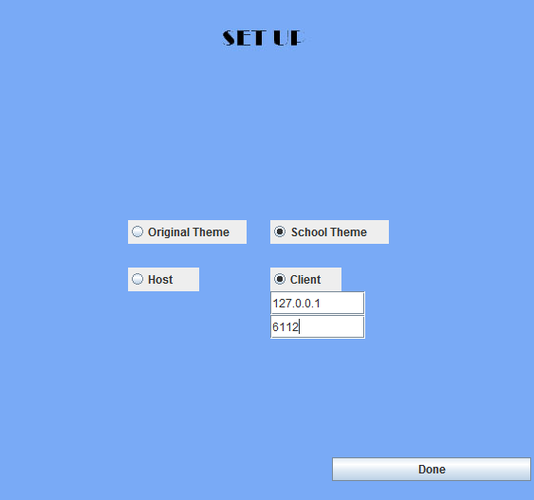

Select this for the school theme of battleship

Done to confirm your choices

When client is selected you will need to enter in your IP Address and port number

**Second theme ship placement screen**

If you make a mistake press reset to reset the board

Press play to confirm your set up

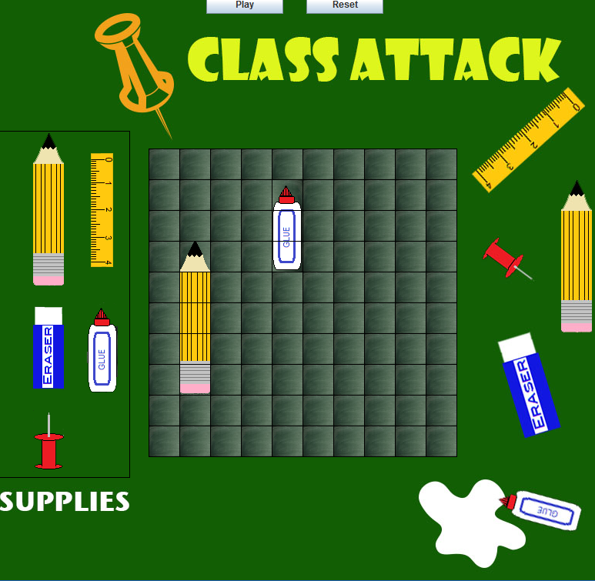

These are the ships for the second theme and you click on one ship to select it to move to the board

The board of the second theme and where you place your ships down

Reset button

To play the game after setting up the ships

**Original screen ship placement screen**

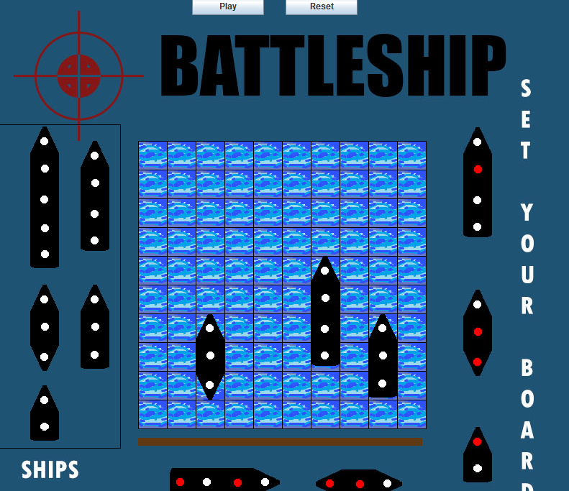

Board to place your ships on, original theme

Ships of the original theme

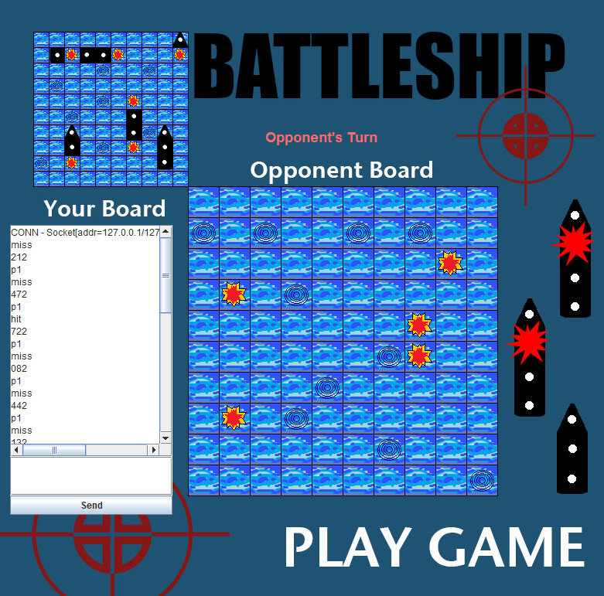 **Original Theme play game screen**

Your board and where the enemy has fired at

The enemy board where you click to shoot at them

The network chat

**Second theme play game screen**

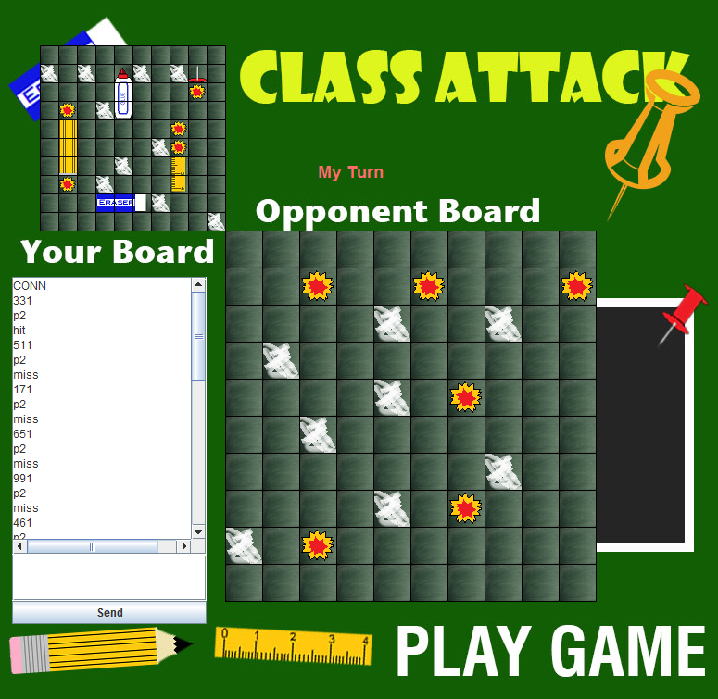

This is your board

The is the enemy board where you shoot at

The chat to talk to the opponent

**Win banner**

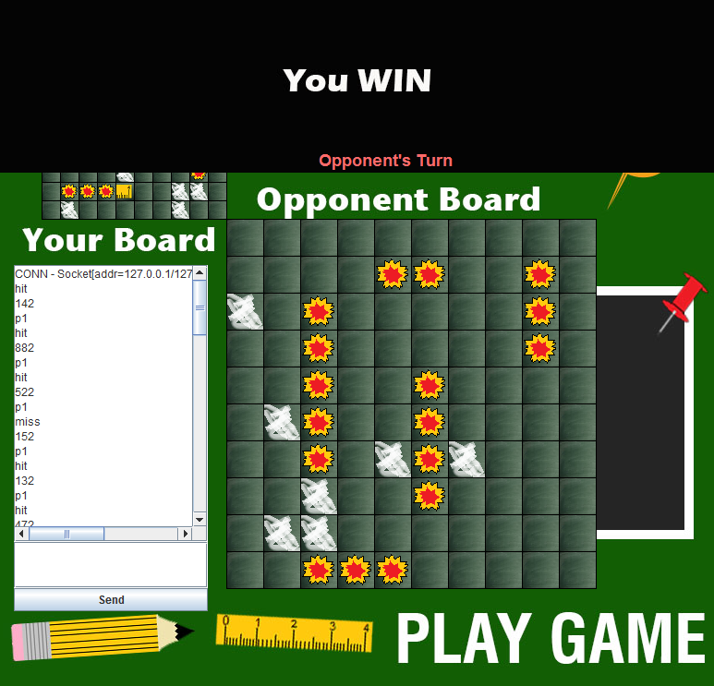

When you win this banner appears

**Lose banner**

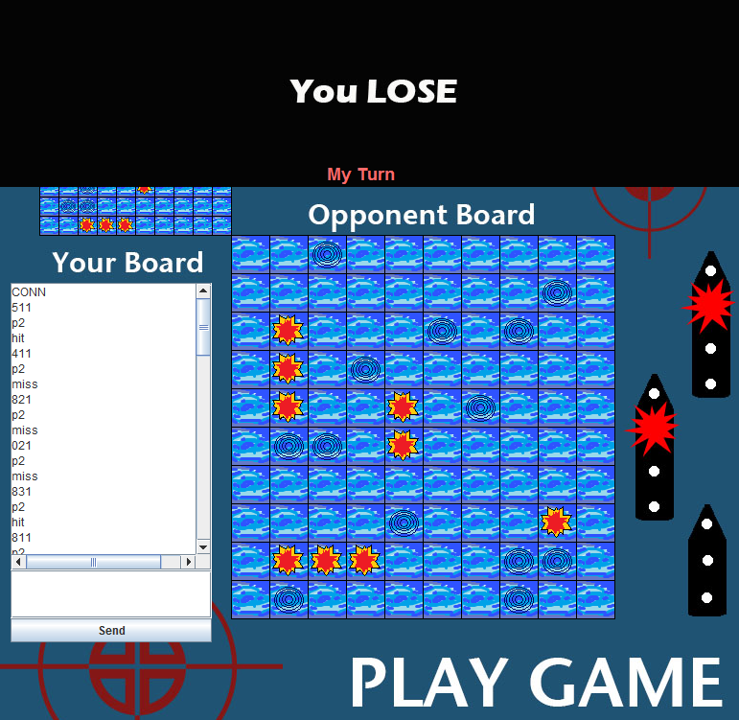

When you lose this banner appears